



Development Standards & Practices Used

* IEEE 5G and LTE standards for software defined radios
* SDR to computer communication standards
* Power delivery standards for SDRs, computer, and amplifier

Summary of Requirements

* Design an enclosure to hold all UE radios and components.
* Test UE connectivity to base station
* Deploy UE around ames
* Perform measurements of reliability and speeds
* Experiment with different software configurations on UEs

Applicable Courses from Iowa State University Curriculum

* CPR E 489 - Computer Networking

New Skills/Knowledge acquired that was not taught in courses

* CAD Modeling
* 5G New Radio
* srsRAN software radio suite

Table of Contents

1 Team **6**

2 **Introduction** **7**

3 Project Plan **8**

3.1 Project Management/Tracking Procedures 8

3.2 Task Decomposition 8

3.3 Project Proposed Milestones, Metrics, and Evaluation Criteria 8

3.4 Project Timeline/Schedule 9

3.5 Risks And Risk Management/Mitigation 9

3.6 Personnel Effort Requirements 9

3.7 Other Resource Requirements 9

4 Design **10**

4.1 Design Context 10

4.1.1 Broader Context 10

4.1.2 User Needs 11

4.1.3 Prior Work/Solutions 11

4.1.4 Technical Complexity 11

4.2 Design Exploration 11

4.2.1 Design Decisions 11

4.2.2 Ideation 12

4.2.3 Decision-Making and Trade-Off 12

4.3 Proposed Design 12

4.3.1 Design Visual and Description 12

4.3.2 Functionality 14

4.3.3 Areas of Concern and Development 14

4.4 Technology Considerations 14

4.5 Design Analysis 14

Design Plan 14

5 Testing **15**

5.1 Unit Testing 15

5.2 Interface Testing 15

Integration Testing 15

System Testing 15

Regression Testing 16

Acceptance Testing 16

Security Testing (if applicable) 16

Results 16

6 Implementation **16**

7 Professionalism **17**

7.1 Areas of Responsibility 17

7.2 Project Specific Professional Responsibility Areas 18

7.3 Most Applicable Professional Responsibility Area 20

8 Closing Material **20**

8.1 Discussion 20

8.2 Conclusion 20

8.3 References 20

8.4 Appendices 21

8.4.1 Team Contract 21

List of figures/tables/symbols/definitions

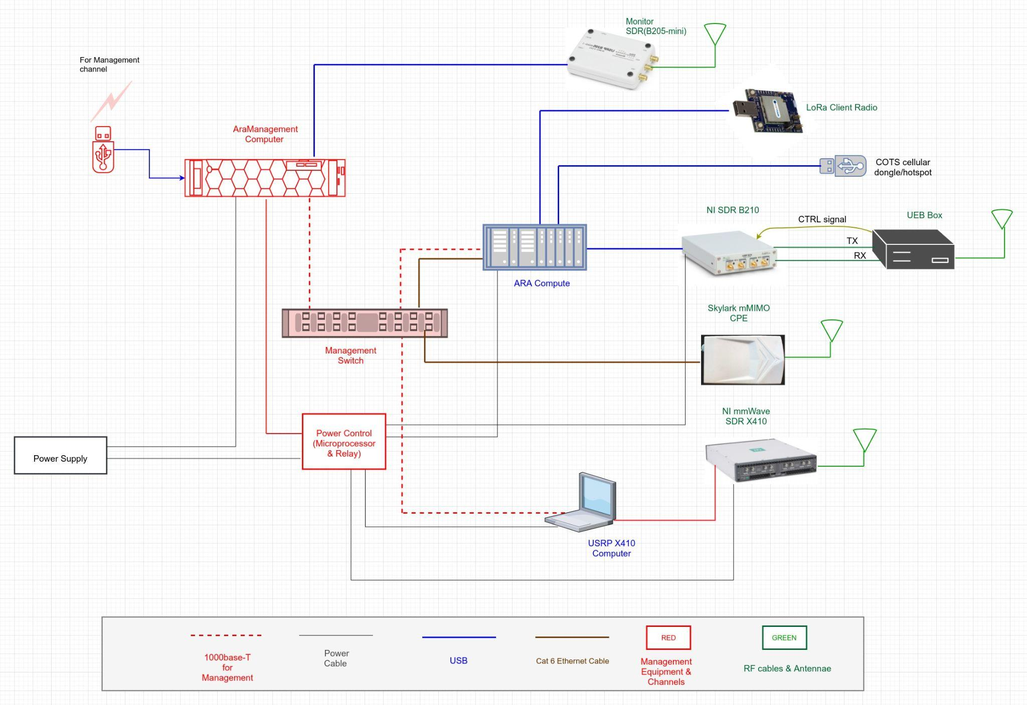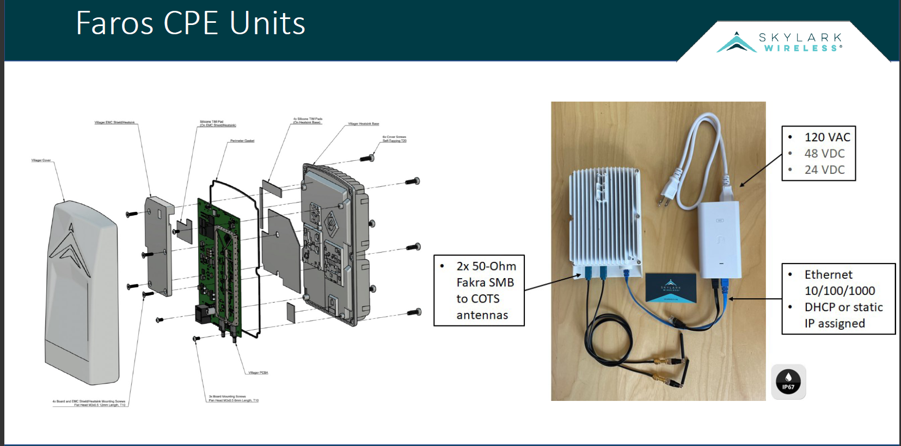

SDR: Software defined radio, these are FPGAs that perform the signal processing needed for radio communication. 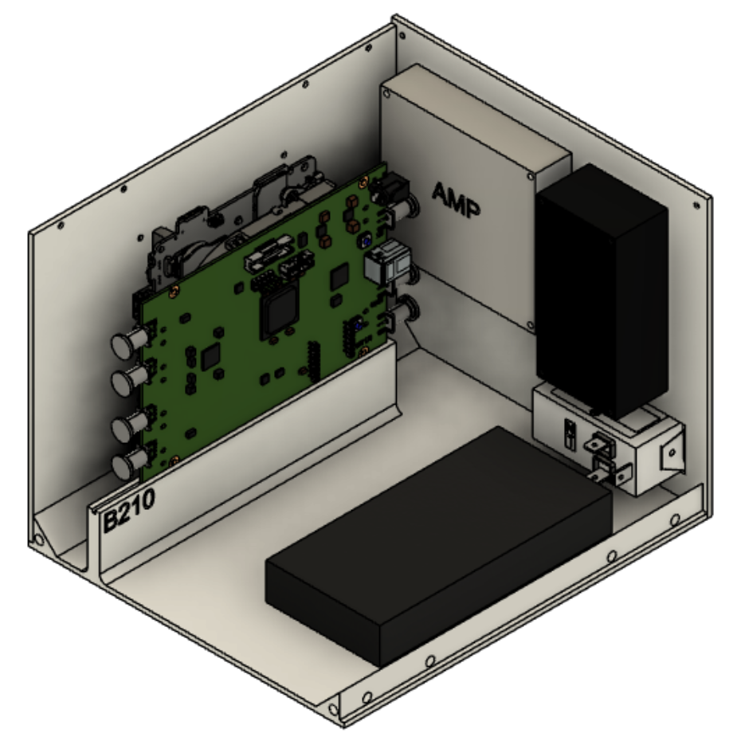

srsRAN: an open-source 4G and 5G software radio suite

UE: User equipment, this is the enclosure that houses all the components

# Team

* 1. Team Members

Johnathan Leisinger

Josh Guyer

Josh Naber

Connor Kesterson

Nick Garrelts

Raffael Neuser

Ruofeng Gao

* 1. Required Skill Sets for Your Project

Leadership, Documentation, Communication, Technical experience, Hardware background, Programming

* 1. Skill Sets covered by the Team

Leadership - Josh Guyer

Documentation - Connor Kesterson, Ruofeng Gao, Joshua Naber

Communication - Nick Garrelts, Johnathan Leisinger, Joshua Naber, Raffeal Neuser

Technical Experience:

Hardware: Josh Guyer, Johnathan Leisinger, Raffael Nesuer

Software: Connor Kesterson, Nick Garrelts, Joshua Naber, Ruofeng Gao

* 1. Project Management Style Adopted by the team

The team adopted two separate groups working on two different aspects of the project. One group is for the software side which is led by Jonathan Leisenger and the other group is the hardware group which is led by Josh Guyer. Each team exchanges information on what they have been working on each week within our scheduled team weekly meetings.

* 1. Initial Project Management Roles

User Equipment hardware group: Josh Guyer(Leader), Josh Naber, Raffael Neuser

User Equipment software group: Johnathan Leisinger (Leader), Connor Kesterson, Ruofeng Gao, Nick Garrelts

# Introduction

* 1. Problem Statement

This project aims to help develop and deploy the user equipment hardware and software needed to be able to communicate with base stations located around ames. The hardware side involves creating an enclosure to encase multiple SDR’s (software defined radios) and components while the software side aims to deploy the software within the UE (user equipment) computers to allow for communication with the base stations.

* 1. Requirements & Constraints

Design an enclosure to hold all UE radios and components.

Test and verify UE connectivity to base station

Deploy UE around ames

Perform measurements of reliability and speeds

Experiment with different software configurations on UEs

* 1. Engineering Standards

IEEE 802 5G standards will be referenced to conform code modifications to open-source software

Use of industry-accepted hardware standards for software defined radios (SDRs) and antennas to achieve the listed network spec constraints above.

IEEE 1914.1 standard for Fronthaul Transport Networks (FTNs) will be referenced when defining what type of user-equipment network is being setup up

* 1. Intended Users and Uses

Researchers

* Researchers will be able to remote into the ARA network and test different configurations of software.
* Enables the study of multi-modal, long distance, and high-throughput wireless backhaul communication and networking.
* Enables research of applications involving wireless networks, fiber networks, edge/cloud computing, AR/VR based agriculture education, and tele-operation of agricultural vehicles.

Rural Communities and Agriculture participants

* The increased capacity and high speed network provided by 5G allows for smart agriculture and industrial automation

# 3 Project Plan

## 3.1 Project Management/Tracking Procedures

Waterfall project management would fit our project the best because the tasks we are completing don’t require incremental steps. Our project follows a linear path of development with some hard deadlines for demonstration. Our team is using Jira to track issues and progress throughout the project. We also plan on using Gitlab for any software repositories we have.

## 3.2 Task Decomposition

1. Design an enclosure to hold multiple SDR’s and Intel NUC. (User Equipment aka UE)
2. Modify srsRAN code to support enclosures of multiple ranges.
3. Deploy UE’s across Ames
4. Perform testing on the UE’s (enclosures) to verify proper functionality.
5. Implement optimization algorithms on the SDRs to help performance.
6. Experiment with open source 5G-and-beyond solutions on the network.

## 3.3 Project Proposed Milestones, Metrics, and Evaluation Criteria

1. October 29th: Design an enclosure that will contain the Intel NUC, an amplifier, and 3 SDRs; B210, X410, and Skylark.
2. November 29th: Test the UE in the lab for reliability and stability
3. December 10th: Print and assemble the enclosure
4. December 14th: Demo the UE enclosure to the National Science Foundation
5. February 15th: Deploy UE’s across Ames and ISU and get measurements or reliability
6. March 15th: Experiment with 5G-and-beyond software platforms
7. April 1st: Conduct performance measurement
8. April 29th: Demonstration/Report

## 3.4 Project Timeline/Schedule

1. August - September 2021: Study basics of the ARA project (https://arawireless.org) and related 5G-and-beyond hardware and software platforms
2. October – November 2021: Develop hardware integration and manufacturing strategies for ARA user equipment; deployment ARA base station equipment; perform initial testing;
3. December 2021 - January 2022: Deploy ARA user equipment across City of Ames and ISU Research and Teaching Farms and conduct performance measurement;
4. January - February 2022: Participate in the preparation of the ARA deployment around the ISU Curtiss Farm as well as Agronomy and Ag Engineering Farm; Experiment with open-source 5G-and-beyond software platforms using ARA;
5. March – April 2022: Experiment with novel 5G-and-beyond solutions and conduct performance measurement; demonstration and report.

## 3.5 Risks And Risk Management/Mitigation

* Equipment breaks: 0.01
* 3D printing errors: .15

## 3.6 Personnel Effort Requirements

| Task | Man-hours |
| --- | --- |
| 3D model an enclosure | 30 hours |
| 3D print the enclosure | 100 hours |
| Modifying the srsRAN codebase for each UE | 60 hours |
| Deploying the UE | 5 hours |
| Testing UE in the lab and in the field | 30 hours |

## 3.7 Other Resource Requirements

* CAD access to design enclosure
* 3D printing materials to print enclosure
* Screws and other hardware to assemble the enclosure
* Computers to modify srsRAN code
* The SDRs needed for this project
* Intel NUCs and amplifiers for the box.

# 4 Design

## 4.1 Design Context

Our design is split up into two things we are working on, software and hardware. The hardware part of the project is creating and testing enclosures that can hold all of the necessary UE so that they can be deployed around Ames for testing. The software side of the project is researching and improving the current srsRan algorithms that we are currently using to improve performance as much as possible.

### 4.1.1 Broader Context

Our project is targeted in Ames and the surrounding area for agricultural use. With 5G implemented, it allows for many low power user devices to be connected to the internet in a large area. 5G will provide fast, reliable internet connection for many different use cases.

List relevant considerations related to your project in each of the following areas:

| **Area** | **Description** | **Examples** |
| --- | --- | --- |
| Public health, safety, and welfare | It gives rural area citizens access to 5G wireless for agricultural use. | Increases agricultural production around the Ames area benefiting agricultural workers. |
| Global, cultural, and social | Our project involves finding users to deploy UEs in people’s environments. | User’s displeasuring of deploying 5G equipment in a lot of areas in their community. |
| Environmental | No real environmental effects. Base stations use some energy and the enclosures are printed out of plastic (3D printing). | Mass production of enclosures may lead to a lot of waste when/if discarded (since our current method is 3D printing with plastic) |
| Economic | Increasing rural economic output through improvement in agriculture. | More sophisticated wireless tech deployed in agriculture, ie autonomous tractors.  Better wireless access to rural communities which increases connectivity and educational opportunities. |

### 4.1.2 User Needs

Rural communities need a better way to connect to the internet because existing infrastructure is lacking. 5G provides a faster and more stable connection than existing tech nologies.

Industrial and agricultural industries can benefit from increased connectivity by deployment of 5G technologies. Connected devices like various sensors for soil, plants, etc require a solid internet connection.

Hospitals, police, and first responders also benefit from increased connectivity.

### 4.1.3 Prior Work/Solutions

<https://book.systemsapproach.org>: Covers general information about computer networking.

<https://5g.systemsapproach.org> : This book provides background information on 5G architectures, which helps develop a baseline understanding of the technology.

<https://www.ece.iastate.edu/~hongwei/group/publications/PRKS-TWC.pdf>: Paper written by faculty adviser that explains the per-packet delivery reliability method. This reliability measure is used as a constraint on network communications.

### 4.1.4 Technical Complexity

Our design contains many devices that we have to account for which are shown in an image in section 4.3.1. We have to be able to make holders for these devices within the enclosure so that they do not move through different measurements such as thickness of material based on device size and holder sizes. Another piece of the project that is down the road is modifying srsRAN algorithms to schedule packets for maximum network reliability. This requires knowledge of not only srsRan coding but also how the current algorithms work.

## 4.2 Design Exploration

### 4.2.1 Design Decisions

For our enclosure we decided to do initial prototyping using 3D printing in the student innovation center using plastic (PLA filament). The physical components/devices that are going into the enclosure are the intel nook, B210 SDR, an amplifier, a transformer, skylark MIMO, X410 SDR, and a power supply. For the software design we just recently got a testbed set in a lab and we are working on getting access to the room so we can start testing srsRAN code.

### 4.2.2 Ideation

When thinking of potential materials to build our enclosure out of, we have to think about the environment that the enclosure will be in. Since this enclosure will be inside to begin with, we need a material that we can easily prototype with minimal cost.

Options: 3D printing filament, Steel, Aluminum, Wood, fiberglass

For this decision, we decided to prototype using 3D printing because it is relatively cheap and fast

### 4.2.3 Decision-Making and Trade-Off

In our process to identify the pros and cons of each material, we mainly focused on 1. the cost of the material 2. how easy it is to manufacture. 3. How well it holds up against outside weather conditions (for future manufacturing).

We decided to choose 3D printing filament at the beginning of the project in order to first get a prototype of the enclosure we want to build. 3D printing is cheap and we can test a lot of different designs without it being too expensive. Once we have completed this we are discussing using steel or aluminum in the final product.

## Proposed Design

So far we have created a design in fusion 360 that we are currently working on printing. The design in fusion 360 is shown in an image in 4.3.1. As for software we have a testbed set up and just completed researching srsRAN algorithms/coding and we are now deciding how we should modify the current code we have.

### 4.3.1 Design Visual and Description



The first image in the images above shows the UE as well as how it is all connected. The second image is our Fusion 360 design that we are currently working on 3D printing for our initial enclosure prototype.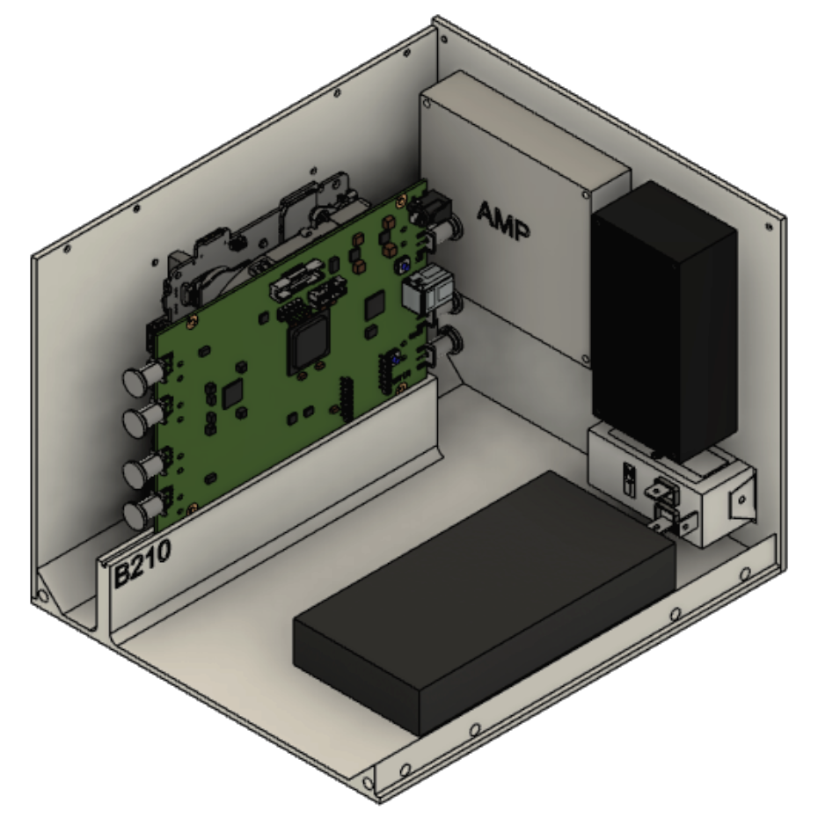

### 4.3.2 Functionality

This enclosure is going to be able to be deployed anywhere with access to power. It will sit all on its own with the desired hardware and communicate with a nearby base station. The user will not need to modify the enclosure or mess with anything inside for it to work properly. Our current design allows for different SDRs to be put in the enclosure making it modular and fit many different use cases.

### 4.3.3 Areas of Concern and Development

As of now our biggest concern is whether or not the X410 SDR is going to fit into our current enclosure design. We are working on getting better specs for it so we can model it inside of our enclosure design.

## 4.4 Technology Considerations

For technology we have to use all of the devices shown in the figure of section 4.3.1 because that is all that we have to work with for the UE.

## 4.5 Design Analysis

We are still working on 3D printing our design so we are unsure if it works as of right now.

We will most likely have to modify our enclosure design once we find out the specs for the X410 SDR.

## Design Plan

Our current design fits all of our given constraints except fitting the X410 SDR in the enclosure (all other UE is fitted). We are still working on a solution for that portion of the design. As for our software we have our testbed set up and we are waiting on getting access to the room before we can test our current code.

# 5 Testing

## 5.1 Unit Testing

The algorithms that are implemented on the radios are what need to be tested. These can be tested by creating a test environment in which modifications can be made and performance differences can be measured. The computer and components are the only tools we need to test modifications to software. The software we are using, srsRAN, also has end-to-end LTE tests that can be used to measure bandwidth.

In regards to the enclosure, units being tested would be the enclosure’s dimensions. Iterating through multiple design prototypes and 3D printing them to make sure they work as intended.

## 5.2 Interface Testing

The interfaces in our design include the enclosure for the B210, Skylark mMIMO, X410 with all devices inside and hooked up as well as the software that is run on them. The enclosure can be tested through ensuring that the dimensions are correct after it is printed and then making sure that the power supply can support all the devices. At the same time we have to make sure the software that we modify is actually making a difference in latency between devices for the software side of things. This can be seen when running the srsRAN program and we will also visibly be able to see if all the devices are receiving the necessary power supply to be turned on.

## Integration Testing

Integrating software algorithms onto the hardware enclosures is key to the success of our design. Testing the wireless speeds will provide us with an assessment of the validity of our design on both the hardware and software ends. If either of these parts is not designed correctly could result in not meeting the speed and latency requirements. Github tests can provide these metrics.

## System Testing

System testing is a level of testing that data completeness and fully integrated product. Testing the full application including external peripherals in order to check how the components interact with the whole system. Parts of unit testing to test the system would be the dimensions of the enclosure and speed of the algorithms. To verify the whole system’s interfaces work would be to perform diagnostics on the hardware components to make sure they function together as expected. Integration testing of the system would be to test run speed tests on the prototype.

## Regression Testing

The only thing that would probably be applicable to regression testing would be the software. In order to ensure we do not take steps backwards when editing the software we will always keep the originals so we have something to look back on if we somehow decrease performance after certain modifications.

## Acceptance Testing

For our project, acceptance testing would involve showing our advisor that the software enclosed in the UE system can successfully communicate with the base station. This communication will have to be reliable and reach the specified upload and download speed. Our team will also have to show our advisor that the enclosure we created is sturdy and can enclose all of the required hardware.

## Security Testing (if applicable)

N/A

## Results

This will be graphs comparing the performance and measurements of different algorithms on different SDRs. We expect the results of the tests to provide similar benchmarks to similar implementations with no significant decrease in signal performance and possibly better performance with the software algorithms.

# 6 Implementation

The plan for implementation next semester is to print an enclosure and test the equipment inside the enclosure to verify the dimensions and constraints work. Simultaneously, we will implement software on a testbed by modifying parts of the srsRAN code to perform required speed and latency specifications. Once it is tested on the development environment, we will integrate our code into the equipment-enclosure unit. Then, we will have a working hardware/software prototype that can be used for testing in the field environment.

# 7 Professionalism

## Areas of Responsibility

| Area of responsibility | Definition | NSPE Canon | IEEE code of ethics | How are they different? |
| --- | --- | --- | --- | --- |
| Work Competence | Perform work of high quality, integrity, timeliness,  and professional competence | Perform services only in areas of their competence;  Avoid deceptive acts | To maintain and improve our technical competence and to undertake technological tasks for others if qualified by training or experience, or after full disclosure of pertinent limitations. | NSPE and IEEE are very similar in their wording, but NSPE mentions avoiding deceptive acts where IEEE does not. |
| Financial Responsibility | Deliver products and services of realizable value and  at reasonable costs | Act for each employer or client as faithful agents or  trustees | To reject bribery in all its forms | IEEE doesn’t mention the financial responsibility that, but instead, says that bribery should be avoided. |
| Communication Honesty | Report work truthfully, without deception, and  understandable to stakeholders | Issue public statements only in an objective and  truthful manner; Avoid deceptive acts | to be honest and realistic in  stating claims or estimates  based on available data. | IEEE includes making sure that  claims are realistic and are based on  available data while NSPE does not  mention those. |
| Health, Safety,  Well-Being | Minimize risks to safety, health, and well-being of  stakeholders | Hold paramount the safety, health, and welfare of the  public. | To accept responsibility in making decisions consistent with the safety, health, and welfare of the public | IEEE makes sure to include accepting responsibility in decisions as well as avoiding injuries to others, their property, reputation, or employment by false action. IEEE covers a larger amount of area. |
| Property Ownership | Respect property, ideas, and information of clients  and others. | Act for each employer or client as faithful agents or  trustees. | to avoid injuring others, their property, reputation, or employment by false or  malicious action | IEEE does not specifically include ideas or information under property, and they use the word “injure” instead of “respect” |
| Sustainability | Protect environment and natural resources locally  and globally | Adhere to principles of sustainable development to protect the environment for future generations | to accept responsibility in making decisions consistent with the safety, health,  and welfare of the public, and to disclose promptly factors that might endanger  the public or the environment | IEEE includes additional guidance for the welfare of not just the environment but also the public, and states that any harmful factors should be disclosed promptly |
| Social Responsibility | Produce products and services that benefit society  and communities | Conduct themselves honorably, responsibly,  ethically, and lawfully so as to enhance the honor,  reputation, and usefulness of the profession | To improve the understanding of technology; its appropriate application, and potential consequences | IEEE focuses on technology while NSPE is about overall conduct |

## 7.2 Project Specific Professional Responsibility Areas

1. Work competence most definitely applies to our project because we are expected to create an enclosure for all of the UE that we are using to deploy 5G around Ames. Currently our group is modeling a design in CAD which will be 3D printed as a prototype. No one in our group has previously used CAD or done any 3D printing so members had to improve technical knowledge by learning how to use solid works as well as how to work the 3D printers.
2. The area of financial responsibility as defined by the IEEE code of ethics has a rare possibility of applying to our project. Our team has not received any bribes as of this moment, so the area of financial responsibility does not currently apply.
3. Communication honesty does apply to our project because we are responsible for having meetings with our mentor as well as a presentation at the end of the semester. It is important that we honestly provide information based on what we are currently working on. Our team is performing “High” on this because we're honest every week with our mentor on what we're working on.
4. Health, safety, and well being plays a small role in our project. One of our tasks is 3D printing, which we are taking all the necessary precautions such as wearing eye protection and becoming certified by taking a training course.
5. Property ownership is a large part of our project, as almost all of what we will be working with has been already purchased and is quite sensitive and expensive. As of right now, our team is performing “High” in this area by handling each of the products, both in hardware and in software, with care. In addition, we are informing ourselves about the software that we are working with so that damage due to ignorance or negligence does not happen in that aspect.
6. Sustainability doesn’t particularly have much to do with our project either. The way our project is set up we are using little to none in terms of natural resources. Also our deployment will in no way harm the environment.
7. Social responsibility does have a role in our project as we are making a product that could benefit society. Our team is performing “High” on social responsibility as we are identifying ways to best implement our products for the general public like minimizing the size of the hardware for public use.

## 7.3 Most Applicable Professional Responsibility Area

Social responsibility is the most applicable professional responsibility to our project because we are developing a service that will benefit all community members in the area as well as research groups. Many people will be able to use this service to enhance their work or make their lives easier. This 5G infrastructure should be beneficial to everyone and will be able to be upgraded in the future when newer technology releases.

# 8 Closing Material

## 8.1 Discussion

So far we currently do not have any results for our project just yet. Once we finish 3D printing our enclosure for the UE, we will be able to define the results for that.

## 8.2 Conclusion

So far our team has done the research behind learning about 5G and what implementations it could have. After our research, the hardware team started to create concepts and prototype designs of a possible enclosure for the user equipment. The software team started to test the srsRAN code on a testbed that was provided to us by our mentor.

The main limiting factor this semester was learning all of the new material that we had limited exposure to. The main bulk of time was put into researching 5G and the srsRAN open source code that we could use to support 5G on the UE’s.

## 8.3 References

<https://arawireless.org/>

<https://5g.systemsapproach.org/>

<https://www.srslte.com/>

<https://openairinterface.org/>

### 8.4.1 Team Contract

**Team Members:**

1) Josh Guyer 2) Connor Kesteson

3) Johnathan Leisinger 4) Ruofeng Gao

5) Joshua Naber 6) Nicholas Garrelts

7) Raffael Neuser

**Team Procedures**

1. Day, time, and location (face-to-face or virtual) for regular team meetings:
   1. We have a discord server in which we can have regular virtual meetings when needed. Face-to-face meetings can be scheduled to meet in the Student Innovation Center in one of the meeting rooms or lab 3038 in Coover.
2. Preferred method of communication updates, reminders, issues, and scheduling (e.g., e-mail, phone, app, face-to-face):
   1. Communication will be conducted over our Discord server.
3. Decision-making policy (e.g., consensus, majority vote):
   1. Majority vote
4. Procedures for record keeping (i.e., who will keep meeting minutes, how will minutes be shared/archived):
   1. Meeting notes and agendas will be compiled onto our teams channel with Hongwei

**Participation Expectations**

1. Expected individual attendance, punctuality, and participation at all team meetings:
   1. We expect people to participate in as many meetings as they can, if they cannot attend, we expect a notice ahead of time of their absence.
2. Expected level of responsibility for fulfilling team assignments, timelines, and deadlines:
   1. We expect everyone to fulfill their assigned task within the deadline. If they are unable to do so, then they should reach out for help to make sure everything gets done on time.
3. Expected level of communication with other team members:
   1. We expect everyone on the team to communicate any advancements related to the project in the Discord. Everyone should be regularly communicating in Discord.
   2. We expect we have great and effective communication with each team member, and all team members show respect for different opinions and reach a consensus
4. Expected level of commitment to team decisions and tasks:
   1. Everyone should participate in team decisions about the project and they should complete the same amount of work as everyone else. We will try to balance the amount of work that everyone gets assigned, taking into account people’s freetime.

**Leadership**

1. Leadership roles for each team member (e.g., team organization, client interaction, individual component design, testing, etc.):
   1. All team members will do their own research for the project. The work will be divided up evenly among the team members as it is assigned. Each team member can communicate with the professor on their own instead of having one person. We will communicate with the professor through Microsoft teams.
2. Strategies for supporting and guiding the work of all team members:
   1. Team members can update the rest of the team on their progress to make sure they stay on track. If a team member gets behind on their work, then another member should help them complete their task.
3. Strategies for recognizing the contributions of all team members:
   1. A way to keep track of the contributions of all team members is to keep track of the tasks that were assigned to them and that they have completed using gitlab.

**Collaboration and Inclusion**

1. Describe the skills, expertise, and unique perspectives each team member brings to the team.
   1. Joshua Naber
      1. Networking and Signals and Systems classes
      2. Assembly language and C
   2. Johnathan Leisinger
      1. Communications classes (EE 321,EE 422, EE423)
      2. SMD soldering
   3. Josh Guyer
      1. Networking and communication class
      2. Signals and systems class
   4. Nicholas Garrelts
      1. Worked in 5G research group
      2. Taken signals and control systems classes
   5. Raffael Neuser
      1. Networking class
      2. Some experience with SDRs
   6. Connor Kesterson
      1. Taken EE 321/422/423 (Communication systems classes)
      2. A lot of MATLAB/Simulink experience
   7. Ruofeng Gao

i. Java, C, some of Assembly language, Linux

ii. Network security(Cpre 430) and knowledge of Internet of Things

1. Strategies for encouraging and support contributions and ideas from all team members:
   1. We encourage every team member to discuss their own idea, and we will collect and adopt the most appropriate and effective idea.
2. Procedures for identifying and resolving collaboration or inclusion issues (e.g., how will a team member inform the team that the team environment is obstructing their opportunity or ability to contribute?)
   1. If a team member is having difficulty contributing to the project, they can bring it up to the team or another member of the team so that the problem can be addressed and resolved.

**Goal-Setting, Planning, and Execution**

1. Team goals for this semester:
   1. Research and learn about 5G and how it can be implemented.
2. Strategies for planning and assigning individual and team work:
   1. Issues can be created in gitlab and assigned to people. The assigning process will be volunteer based, trying to split up the work evenly. If one person is taking on more of the work, they should give up some to someone who has done less.
3. Strategies for keeping on task:
   1. Having a schedule of set milestones will keep us on track of what we need to do.

**Consequences for Not Adhering to Team Contract**

1. How will you handle infractions of any of the obligations of this team contract?
   1. If one infraction is exercised by a team member, the team will talk to the individual about it to address the issue.
2. What will your team do if the infractions continue?
   1. If infractions keep continuing, the professor will need to be contacted in order to solve the problem.

***************************************************************************

a) *I participated in formulating the standards, roles, and procedures as stated in this contract.*

b) *I understand that I am obligated to abide by these terms and conditions.*

c) *I understand that if I do not abide by these terms and conditions, I will suffer the*

*consequences as stated in this contract.*

1) Josh Guyer DATE 9/17/21

2) Connor Kesterson DATE 9/17/21

3) Joshua Naber DATE 9/17/21

4) Nicholas Garrelts DATE 9/17/21

5) Johnathan Leisinger DATE 9/17/21

6) Ruofeng Gao DATE 9/17/21

7) Raffael Neuser DATE 9/17/21